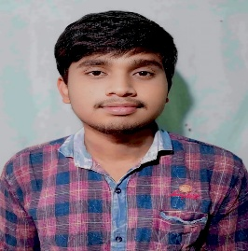
SUDIP MAITY
Narma, Narayangarh , West Medinipur – 721166
 +91-9641665151
 sudipmaity0173@gmail.com
Date of Birth:-10/09/2004
Academic Details :-
Degree | Institution | Year | SGPA/  Percentage
Bachelor of Technology in Computer science Engineering | Brainware University | 2023 to present | 7.60/73.50%  (Aggregate till semester-|||)
Higher Secondary (12th) | Madanmohanchak Chowdhury Institution | 2021-2023 | 57.2%
Secondary (10th) | Madanmohanchak Chowdhury Institution | 2020-2021 | 77%

Career Objective :-
Motivate computer science graduate with strong problem-solving skills, seeking a challenging role in web development to apply my programming knowledge and grow with organization .
Technical Skills :-
Programming Languages:- Little more know about C, JAVA, PYTHON
Web Technologies :- Know about HTML and also learning about CSS & JavaScript
Tools:- VS Code, MS Office
Projects:-
- Portfolio Webpage – A responsive and visually appealing personal portfolio website.
- Shopping Web page - Link
Language :-
- Bengali :- Read ,Write &Speak.
- English :- Read ,Write & Speak.
- Hindi :- Speak.

